Tarea 5

Salguero Hernández Juan Pablo



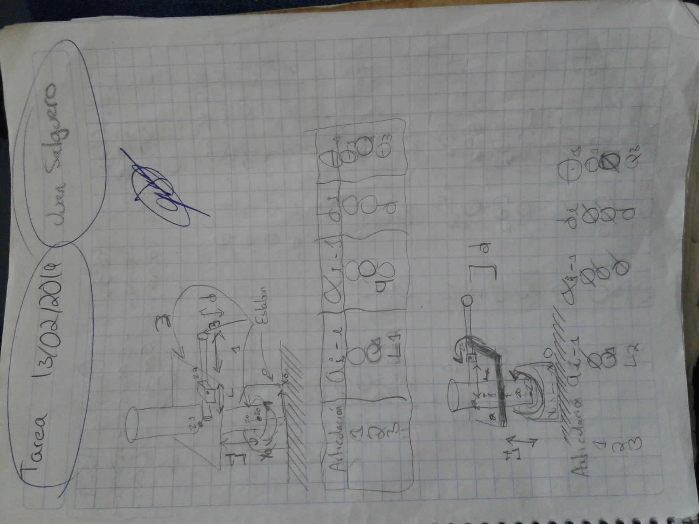

**Obtención de la cinemática directa de Robots**

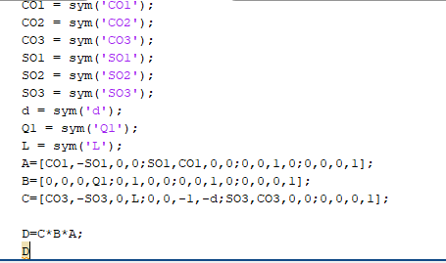

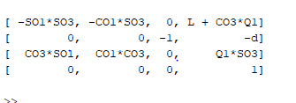

|  |  |  |  |  |
| --- | --- | --- | --- | --- |
| Eslabón | $$A_{i-1}$$ | $$α_{i-1}$$ | d $i$ | $$θi$$ |
| 1 | **0** | **0** | **0** | $$θ_{1}$$ |
| 2 | **Q1** | **0** | **0** | **0** |
| 3 | $$L_{1}$$ | **90** | **d** |  |

|  |  |  |  |  |
| --- | --- | --- | --- | --- |
| Eslabón | $$A_{i-1}$$ | $$α_{i-1}$$ | d $i$ | $$θi$$ |
| 1 | **0** | **0** | **0** | $$θ_{1}$$ |
| 2 | **Q1** | **0** | **0** | **0** |
| 3 | $$L_{1}$$ | **0** | **d** | $$θ_{3}$$ |

